**Purpose**

We will investigate the properties of several resistors connected in series and parallel. Our purpose is to verify the simple equations for the equivalent resistors (Req) in series and parallel connections, and to verify the current relations when a potential is placed across a network (circuit) connecting resistors in series or parallel with each other.

**Procedure**

**I: Series connections properties.** We selected tree resistors, 1000Ω, 1500Ω, and 3300Ω and used an ohmmeter to measure their actual resistance using the DVM. We then connected them in series using the diagram below. Using the DC power supply output on the blue box we supplied 20V across the series connection. The circuit diagram labeled A, B, C, and D represent parts of the circuit where we wish to measure the circuit. An ammeter must be inserted at each of these points.

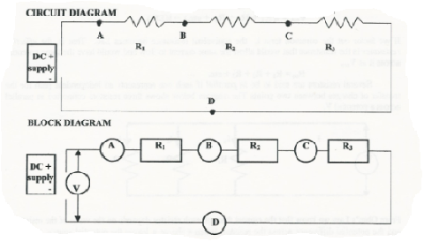

Our goal is to verify the current is the same at each point in a series circuit. In general the procedure consisted of the following steps:

1. Set the function to A (for ammeter), and the rage of your DVM ammeter at 1 A.
2. Break the circuit at A, B, C, or D by disconnecting one at a time, the wire that connects the resistors and adding a wire to the second resistor. The wire closest to the potential source is put into the ammeter input on the DVM, and the second wire is inserted into the COM.
3. Now apply the power to the circuit and lower the range scale to an appropriate value.

After measuring the currents, we then measured the potential differences across each resistor and the potential difference across the entire circuit. In general the procedure consisted of the following steps:

1. Set the DVM to DC voltage, and the range to the highest available.
2. Set the probes of the DVM across the voltage source and record the voltage of the supply.
3. Now place the probes across each resistor and record its potential drop. Lower the range scale to a more sensitive range if necessary.

**II: Parallel connections properties.** Using the same three resistors, connect them in parallel in the circuit shown in the diagram below. Again use the DC power supply output on the blue box to supply a 20V across the series connection. The circuit diagrams labels A, B, C, D, and E show five locations in the circuit where we wish to measure the current. Again in order to measure the current “flowing” through the circuit an ammeter must be inserted at each of these points.

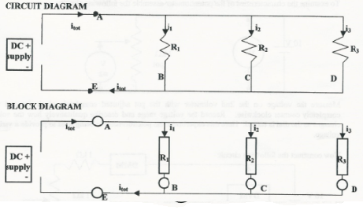

Our goal here is to verify how the currents divide in a parallel circuit. In general the procedure consisted of the same steps

1. Set the function to A (for ammeter), and the range of your DVM ammeter at 1 A.
2. Break the circuit at A, B, C, D or E by disconnecting the wire that connects the resistors and adding a wire to the second resistor. The wire closest to the potential source is put into the ammeter input on the DVM, and the second wire is inserted into the COM.
3. Now apply the power to the circuit and lower the range scale to an appropriate value.

After measuring the currents, we then measured the potential differences. In the case of the parallel connection we expect the voltage to be the same across each resistor.

1. Set the DVM to the DC voltage, and the range to the highest available.
2. Set the probes of the DVM across the voltage source and record the voltage of the supply.
3. Now place the probes across each resistor and record its potential drop. Lower the range scale to a more sensitive range if necessary.

**III: Potentiometers and Rheostats:** there is a simple devise frequently used in circuits which is best described as a variable resistor. It consists of a resistor with a sliding contact which can move from one end of the resistor to the other. This device is called a potentiometer or “pot” for short. It has three contacts, one at each end and one on the slide wire. Connections to this contacts usually are tabs on the outside of the packaged pot.

To measure the characteristics of the potentiometer a simple circuit was assembled.

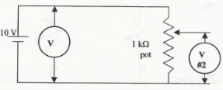

We measure the voltage on the 2nd voltmeter with the pot adjusted completely clockwise and the completely counter clockwise.

We the measured the current change in the following circuit:

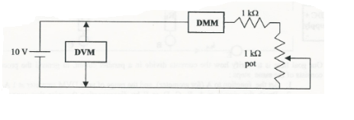

Using the DMM. We measure the maximum and minimum current.

**Data**

**Resistors**

|  |  |  |
| --- | --- | --- |
| **R1**  **(Ω)** | **R2**  **(Ω)** | **R3**  **(Ω)** |
| 988 | 1560 | 3250 |

+ 1 + 1 + 1

**Series Connection**

|  |  |
| --- | --- |
| **iA** | 3.45 mA |
| **iB** | 3.45 mA |
| **iC** | 3.45 mA |
| **iD** | 3.45 mA |

|  |  |
| --- | --- |
| **Vtot** | 20 V |
| **VR1** | 3.4 V |
| **V R2** | 5.4 V |
| **V R3** | 11.2 V |

**Parallel Connection**

|  |  |
| --- | --- |
| **Itot** | 38.4 mA |
| **i1** | 20.3 mA |
| **i2** | 12.4 mA |
| **i3** | 6.1 mA |
| **Itot E** | 38.4 |

|  |  |
| --- | --- |
| **Vtot** | 20 V |
| **VR1** | 19.8V |
| **V R2** | 19.7 V |
| **V R3** | 19.8 V |

**Presentation**

**Series Connection**

Verify: $V_{tot}=iR_{1}+iR_{2}+iR_{3}$

$$=.00345A\left(988 Ω+1560 Ω+3250 Ω\right)=20V$$

$R_{eq}=R_{1}+R_{2}+R_{3}=5798 Ω$

**Parallel Connection**

Verify: $i_{tot}=i_{1}+i_{2}+i_{3}$

$$i_{tot}=38.4 mA$$

$$i_{1}=\frac{V_{R1}}{R_{1}}=\frac{19.8V}{988 Ω}=0.02A=20 mA$$

$$i_{2}=\frac{V_{R2}}{R_{2}}=\frac{19.7V}{1560 Ω}=0.012A=12.6 mA$$

$$i_{3}=\frac{V_{R3}}{R_{3}}=\frac{19.8V}{3250 Ω}=0.0061A=6.1 mA$$

$$i_{1}+i_{2}+i_{3}=20 mA+12.6 mA+6.1 mA=38.7 mA$$

$$\frac{1}{R_{eq}}=\frac{1}{R_{1}}+\frac{1}{R_{e2}}+\frac{1}{R_{3}}=\frac{1}{988 Ω }+\frac{1}{1560 Ω}+\frac{1}{3250 Ω}=.00196 Ω$$

$$R_{eq}=510.2 Ω$$

Calculate the currents i, i2, and i3 for the circuit below. The two resistors are in parallel and the effective resistance of those two are in series with the third.

Circuit here

$$v_{0}=10 v$$

$$v_{1}=10 v$$

$$v_{2}=10 v$$

$$i=5 mA$$

$$i_{1}=\frac{6}{2000 Ω}=3 mA$$

$$i_{2}=\frac{6}{3000 Ω}=2 mA$$

**Conclusion**

In both series and parallel connections, the error percentage was less than 1. This most certainly verifies the equations for equivalent resistance (Req)